Lecture 03 — Modelling Concepts

- What is a Model?
  - Model = simplified/abstract representation of a system.
  - Why models are needed in software development.

Models are needed because software systems are complex, and models help us simplify, understand, communicate, and manage that complexity.

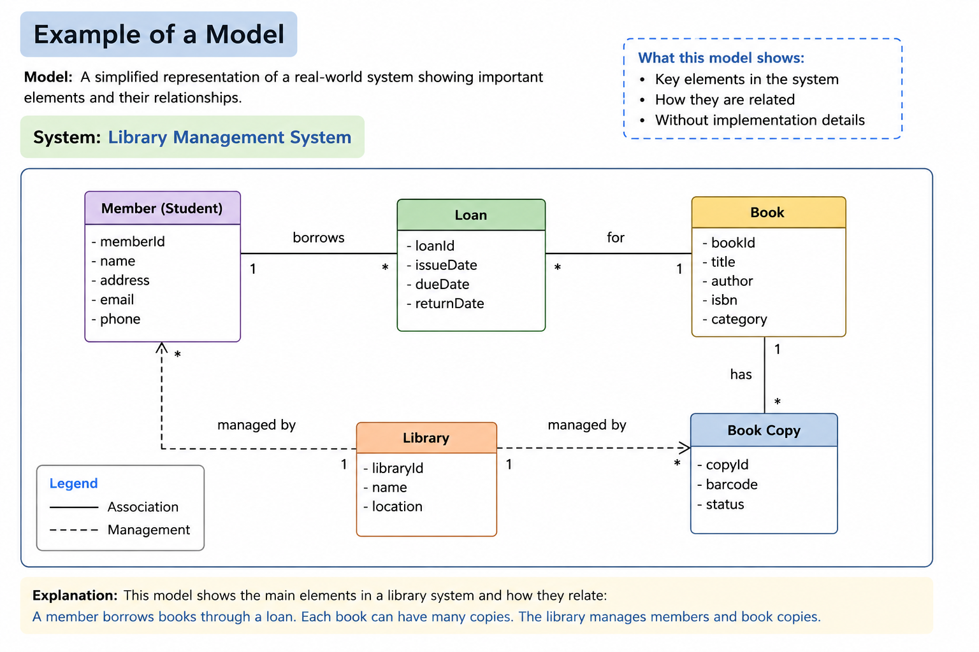

- What is a Diagram?
  - Diagram = a particular view of a model.

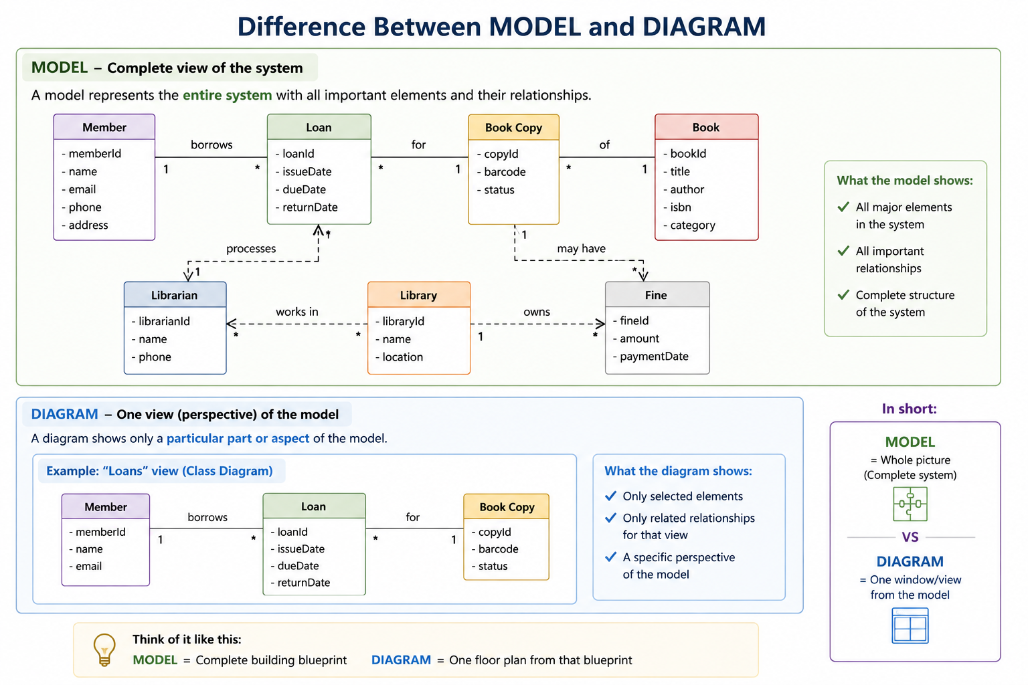

Model = the whole blueprint
It represents the whole system and its important elements and relationships.
Diagram = one view of that model
It shows only a particular part/aspect of the model.
Ex:
Think about a house
Model = the complete idea/representation of the house.
It tells us things about the house:
- Rooms
- Relationships between rooms
- Doors
- Windows
- Structure
- How things are organized
Diagram = one visual way of showing part of that model.
For example:
- Floor plan → shows room arrangement
- Electrical diagram → shows electrical connections
- Plumbing diagram → shows water connections
So:
Model = WHAT we are representing
Diagram = HOW we represent/show it

In software engineering
Suppose we are developing a Library System.
The model represents the system's important concepts and relationships:
Student borrows Book
Librarian manages Book
Book belongs to Library
We can represent different parts of that model using diagrams:
Class Diagram
→ shows classes and their relationships.
Use Case Diagram
→ shows actors and their interactions with the system.
Sequence Diagram
→ shows how objects interact over time.

Model
↓
can be represented using
↓
Diagrams

- Purpose of Diagrams
  - Communicate ideas
  - Understand structure/relationships
  - Test ideas
  - Generate new ideas
- General Rules of Modeling
  - Simplicity
  - Consistency
  - Completeness
  - Hierarchical representation

- What is UML?
  - Unified Modeling Language
  - Purpose and importance
UML as a standard language for specifying, visualizing, constructing and documenting software systems.
- UML Basics
  - Types of UML diagrams:
    - Structure diagrams
    - Behavior diagrams

  - Three UML building blocks:
    - Things
    - Relationships
    - Diagrams

UML Diagram Types
UML diagrams can be grouped into two broad categories:
1. Structural Diagrams
Show what the system is made of — its structure, components, and relationships.
- Class Diagram → classes, attributes, methods, relationships
- Object Diagram → objects and their relationships at a particular time
- Component Diagram → software components and their dependencies
- Deployment Diagram → hardware/devices and where software components are deployed

2. Behavioral Diagrams
Show how the system behaves or works.
- Use Case Diagram → actors and their goals/interactions
- Sequence Diagram → order of interactions between objects
- Activity Diagram → workflow/process of activities
- State Machine Diagram → how an object changes from one state to another

Case Studies

Case Study 1 — University Library
A university library system keeps information about Students, Books, Librarians and Loans. A student can borrow several books. Each book can be borrowed by different students at different times. Librarians manage books and loans.
Students identify:
- What is the model?
- What important things should the model contain?
- Which diagram could represent the model?
- What information would that diagram show?

Answer
1. What is the model?
A model of the University Library System, including students, books, librarians, loans, and their relationships.
2. Important things in the model
- Student
- Book
- Librarian
- Loan
- Student borrows Book
- Librarian manages Book/Loan
3. Suitable diagram
Class Diagram
4. What does it show?
It shows the classes, their attributes/methods, and relationships between them.
Main idea:
The Class Diagram shows the structure of the library system

Case Study 2 — Online Shopping
An online shopping system allows customers to browse products, add products to a cart, place orders and make payments. Administrators manage products and orders. A payment gateway is an external system.
Students identify:
- What aspects of the system need to be modeled?
- What is the model?
- Which diagram could represent:
  - the system's structure?
  - user interactions?
  - the sequence of interactions?
- Explain why each diagram is suitable.

Answer
1. What aspects need to be modeled?
- Customers
- Products
- Shopping Cart
- Orders
- Payments
- Administrator
- Payment Gateway
- Interactions between these entities
2. What is the model?
A model of the Online Shopping System, representing its structure and behavior.
3. Suitable diagrams
What we want to show | Diagram
System structure | Class Diagram
User interactions | Use Case Diagram
Order/payment interaction sequence | Sequence Diagram
4. Why?
Each diagram provides a different view of the same system model

Case Study 3 — Hospital Appointment System
A hospital system contains Patients, Doctors and Appointments. Patients can search for doctors and book appointments. Doctors can view their appointments. An appointment has a date, time and status.
Students identify:
- What is being modeled?
- What are the important concepts/entities in the model?
- Which diagram would best represent the relationships between these concepts?
- What would the diagram show?

Answer
1. What is being modeled?
The hospital appointment system, including patients, doctors, appointments, and their relationships.
2. Important concepts
- Patient
- Doctor
- Appointment
- Date
- Time
- Status
3. Best diagram
Class Diagram
4. What does it show?
It shows the structure of the system and relationships such as:
Patient → books → Appointment
Doctor → has → Appointments
Main idea:
Use a Class Diagram when you want to show what the system is made of and how its elements are related.

Case Study 4 — ATM System
An ATM allows a customer to insert a card, enter a PIN, check balance, withdraw money and receive a receipt. The ATM communicates with the bank system.
Students identify:
- What is the system model?
- Who/what interacts with the system?
- Which diagram would show actors and their goals/interactions?
- Which diagram would show the sequence of interactions during cash withdrawal?

Answer
1. What is the model?
A model of the ATM system, including customers, ATM, bank system, transactions, and their interactions.
2. Who/what interacts with the system?
- Customer
- Bank System
3. Diagram for actors and goals
Use Case Diagram
For example:
Customer → Withdraw Cash
Customer → Check Balance
Customer → Change PIN
4. Diagram for sequence of interactions
Sequence Diagram
For example:
Customer
↓
ATM
↓
Bank System
↓
ATM
↓
Customer
It shows the order in which the interactions happen

Case Study 5 — Food Delivery System
A food delivery system involves Customers, Restaurants, Delivery Drivers and Orders.
A customer places an order from a restaurant. The restaurant accepts the order and prepares the food. A delivery driver collects and delivers it.
Students identify:
- What important aspects of the system should be included in the model?
- Which diagram would represent the structural relationships?
- Which diagram would represent the interaction sequence?
- Which diagram would represent customer interactions with the system?

Answer
1. What should be included in the model?
- Customer
- Restaurant
- Delivery Driver
- Order
- Payment
- Delivery
- Relationships between them
2. Structural relationships
Class Diagram
For example:
Customer → places → Order
Restaurant → prepares → Order
Driver → delivers → Order
3. Interaction sequence
Sequence Diagram
For example:
Customer → Restaurant → Order System → Driver
It shows how the participants communicate step-by-step.
4. Customer interactions with the system
Use Case Diagram
For example:
Customer → Browse Restaurants
Customer → Place Order
Customer → Make Payment
Customer → Track Delivery

